Average Rating:
Rated By: 21 members
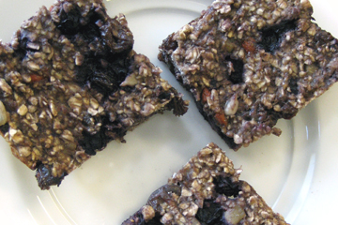

Breakfast

Antioxidant-Rich Breakfast Bars
www.DrFuhrman.com

Serves: 6
Preparation Time: 15 minutes

Ingredients:
1 medium ripe banana
1 cup old fashioned oats
1 cup frozen blueberries, thawed
1/4 cup raisins
1/8 cup pomegranate juice
2 tablespoons finely chopped dates
1 tablespoon chopped walnuts
1 tablespoon Goji berries or other unsulfured dried fruit
1 tablespoon raw sunflower seeds
2 tablespoons ground flax seed
Instructions:
Preheat oven to 350 degrees F.
Mash banana in a large bowl. Add remaining ingredients and mix thoroughly.
Lightly wipe an eight inch square baking pan with a small amount of olive oil. Spread mixture into pan. Bake for 25 minutes. Cool on wire rack and cut into bars.
Refrigerate any leftover bars.

